**GAME DESIGN DOCUMENT**

1

GOD OF WAR

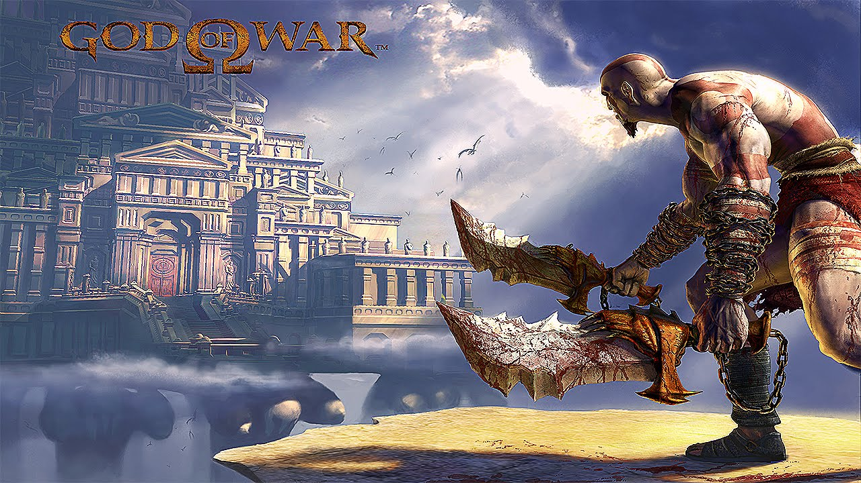

**Last Updated:**

15/1/20

**Prepared By:**

Slaven Branislav Babić

**TABLE OF CONTENTS**

Game Analysis 3

Mission Statement 3

Genre 3

Platforms 3

Target Audience 3

Storyline & Characters 4

Gameplay 5

Overview of Gameplay 5

Player Experience 5

Gameplay Guidelines 5

Game Objectives & Rewards 5

Gameplay Mechanics 5

Level Design 6

Control Scheme 7

Game Aesthetics & User Interface 7

Schedule & Tasks 8

# Game Analysis

This game packs a lot of action with interesting puzzles. It forces player to think and make connections. But for the most part it allows the player just to go on a rampage and kill all of the enemies. As a player you’re following a path which games presents to you and you can’t go anywhere else. Your objective is to kill all of the enemies and develop your skills to defeat bosses and the final boss. You can except intensive gameplay and a lot of satisfaction by killing them in combos. Blades of Kratos are unique weapon which can be used in an unusual way for this kind of games. It offers players interesting storyline which has roots in Greek mythology so if some players are interested in that it can be good hook.

# Mission Statement

You will have your revenge! Nobody will tell you what and how you’ll do it. You will kill everybody who’s in your way to become a god of war and revenge your family from third person perspective in this action-adventure game for PlayStation 2.

# Genre

Action-adventure (combo-based) combat

# Platforms

PlayStation 2

# Target Audience

18+ male audience. Shortest description. People who work a lot and want to relieve themselves from monotony of their work. Instead of going and playing some sports they need something violent where they can hit and smash stuff and kill enemies. Target audience mostly have jobs 9-5 and need some kind of exhaust pipe after work. They like something that is opposite of their boring work and need something that is action packed and that will raise their adrenaline levels. The game is not just about killing but there are some puzzles which will be appealing to other players as well. People who like Price of Persia will definitely like this game. Also, people interested in ancient mythology will appreciate the story. So definitely older audience because younger people don’t really know much about it. Maybe people from Europe and Greece will be more connected to the game, but it is such a popular story and history that everybody can relate to it.

Because there’s a lot of violence it is not targeted to children.

But it is important to note that a lot of school children plays this game. They are not target audience but they are maybe the biggest consumer of the game.

# Storyline & Characters

This is where you present a story synopsis and discuss how the story will unfold as the player makes his or her way through the game. Include information on the key characters in the game, including descriptions, abilities, characteristics, how they fit into the story, how they affect gameplay, what the player will learn from them, etc.

|  |  |  |  |
| --- | --- | --- | --- |
| Character | Description | Characteristics | Misc. Info |
| Kratos | Main character. Drives the story. | Very angry, very capable at killing. Very deadly. Can kill gods. | Present any other notes about the character. |
| Athena | Kind of a tutor which shows you the way through the game and gives explanation for some actions. | Smart, with a lot of knowledge but also capable of intrigues. |  |
| Ares | Main enemy. You need to kill him to become the god of war and finish the game. | Current god of war. Master of chaos and killing. | Made Kratos what he is today. Killing machine. But also, tricked Kratos into killing his family. |

# Gameplay

## Overview of Gameplay

The 1981 film Raiders of the Lost Ark also inspired the development of God of War; he wanted to make players feel like he felt as a child watching that film, but did not want to put the player in the role of an adventurer, referencing The Legend of Zelda games. He elaborated that God of War was designed to be simplistic and forward-moving, but the game "is not innovative or unique, and that's intentional".

## Player Experience

System was shallow and "it forced the team to constantly create new content to trapeze the player from one area of interest to the next". He said he understood modular game design—the need to have great looking, high-detail levels without having to build and texture every minuscule piece of the environment—but "[he] was going to get bored" if they did not step outside of those boundaries.

## Gameplay Guidelines

One of the rules is to restrict areas where player can go. So that level design itself shows the player in which direction to go. One of harder tasks is to position cameras just right so that transition between them is smooth and it doesn’t affect the gameplay.

## Game Objectives & Rewards

|  |  |  |
| --- | --- | --- |
| Rewards | Penalties | Difficulty Levels |
| Defeating enemy gives items necessary to power up. | Falling from the edge makes the player have to do it all over again during “puzzles”. | Intensity increases while the game progresses but it iis a circle. Small enemy, big enemy, boss fight. |

## Gameplay Mechanics

This is the where you start getting more specific on how some of the systems in the game will work. This includes how characters move in the game, what gameplay actions are available, item inventory and attributes, and how the game progresses from level to level.

|  |  |
| --- | --- |
| **Character Attributes** |  |
| **Character** | **Movement Abilities / Actions Available** |
| Kratos | Poseidon rage – liightning which strikes everybody near you  Medusas head – you can freeze the enemy  Zeus power – you can shoot lightning on enemies which are far away |
|  |  |
| **Game Modes** |  |
| Easy, medium, hard | Usual intensity increases |
| **Scoring System** |  |
| **Points/Coins/Stars/Grades/Etc.** | **How it’s Awarded & Benefits** |
| Killing enemies gives you items which you can then use to power up you weapons. |  |

## Level Design

Discuss the levels. How many levels will the game have, what will be included in each level. Include overall look and feel, hazards the level presents, difficulty, objectives, etc.

|  |  |
| --- | --- |
| **Levels** |  |
| Basic lvl fight | Arcade combat on semi open space where you can’t progress until you kill all the enemies. |
| Boss lvl fight | Boss fight in an “arena” where you must defeat the enemy in order to progress. Some special ways of killing are added. |
| Final boss lvl fight | Similar to boss lvl fight but you have to defeat enemy several times in order to win. |

# Control Scheme

Describe the control setup for the game. Does your game use touch input, a controller, or mouse & keyboard? Discuss the functionality of each button/touch. It may help to insert a diagram/pic to help explain the actions.

|  |  |
| --- | --- |
| **Button/ Touch Input** | **Action it Performs** |
| Analog pads  X  Square  Circle  R2  L1 | Moving  Jumping  Attacking  Special sequence of attacks  Open crates and interact with objects  Defense |

# Game Aesthetics & User Interface

Some of this has been said before. Path is straightforward and level design leads the player in forward direction. Game is set in ancient Greece so whole environment reflects that. From ancient statues to big architectural masterpieces in Athena. Every level and fights are enhanced by sound. It is louder and more intense when you are approaching enemies and after the fight is fades away. It is hoped that player will experience dark mood and terrifying surroundings to produce fear in the player.

# Schedule & Tasks

List the tasks that need to be completed along with the basic timeline to complete them by. The task list can be as detailed as you like to fit your studio’s needs. The table below can be substituted for the excel file. This table is a great start, but the tasks should be much more detailed.

|  |  |  |  |  |
| --- | --- | --- | --- | --- |
| **Tasks to Complete & Schedule** | | | | |
| **Tasks** | **Task Lead** | **Start** | **End** | **% Complete** |
| **Development Phase** | | | | |
| Design |  |  |  |  |
| Storyline | Dominik C | 9/4/18 | 9/8/15 | 0 % |
| Level Mechanics |  |  |  |  |
| Art |  |  |  |  |
| Level 1 |  |  |  |  |
| Special FX |  |  |  |  |
| UI |  |  |  |  |
| Engineering |  |  |  |  |
| Production Pipeline |  |  |  |  |
| Prototypes |  |  |  |  |
| Audio |  |  |  |  |
| Sound Design |  |  |  |  |
| Milestone: Game Play Features & Music |  |  |  |  |
| **Testing Phase** | | | | |
| Test Plan |  |  |  |  |
| Beta Testing |  |  |  |  |
| Milestone: QA Testing |  |  |  |  |
| **Deploying Phase** |  |  |  |  |
| "Go Live" Plans |  |  |  |  |
| Milestone: Ready for Usage |  |  |  |  |

Developer(s) SCE Santa Monica Studio

Publisher(s)

WW: Sony Computer Entertainment

JP: Capcom

Director(s) David Jaffe

Producer(s) Shannon Studstill

Designer(s) David Jaffe

Programmer(s) Tim Moss

Artist(s)

Charlie Wen

Terry Smith

Steve "Scat" Caterson

Writer(s)

Marianne Krawczyk

Alexander Stein

David Jaffe

Keith Fay

Composer(s)

Gerard Marino

Mike Reagan

Ron Fish

Winifred Phillips

Winnie Waldron

Cris Velasco

Marcello De Francisci

Series God of War

Engine

Kinetica[a]

Bluepoint Engine[b]

Platform(s)

PlayStation 2

PlayStation 3[c]

PlayStation Vita[d]

Release

March 22, 2005

Genre(s)

Action-adventure

hack and slash

Mode(s) Single-player